Kelso Cricket Club Sponsorship 2019

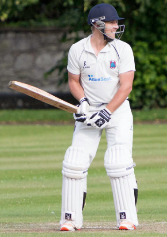
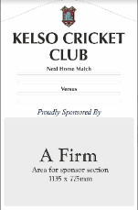
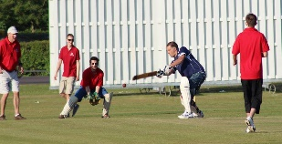
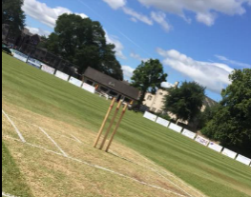
We are very appreciative of the continued support from all of our Sponsors. Please see below our sponsorship opportunities available for the 2019 season:
Player Sponsor

Cost: £50
Features: Company name on KCC website next to player and on Sponsor’s board in the Clubhouse

Name on Fixture Board (2 boards available)

Cost: £750 (£500 for 2nd year and thereafter)
Features: All year round advertising on a fixture board in a permanent place in Shedden Park. (Size 3ft x 4ft)

Name on Sight Screen

Cost: £400 (£300 for 2nd year and thereafter)
Features: Have your company’s name on one permanent sight screen for the 2019 season

Advertising Board

Cost: £360 (£200 for 2nd year and thereafter)
Features: Have your company’s name on an advertising board that will be put up on match days

Home Match Sponsor

Cost: £100
Features: Advertisement on social media and special deals on your company’s sponsorship day

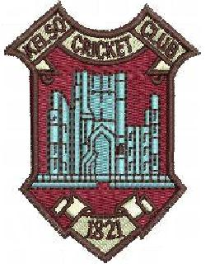
ALL SPONSORS will also receive the following:

- Sponsors Day Invitation
- Name on Sponsor’s board in clubhouse
- Name on Kelso Cricket Club’s website
- Mentions on Kelso Cricket Club’s Facebook page (over 2000 ‘likes’)

If none of the above Sponsorship Opportunities suit your preference, we are very appreciative of any donations. We will ensure your name will be on the Sponsor’s Board inside the pavilion.

How to Sponsor / Discuss Sponsorship

1) Complete and return the enclosed Sponsorship form.

2) Phone/e-mail one the following Committee members:

Chris Grindell (Treasurer):
phone: 07767 332359 • e-mail: chris.grindell@btconnect.com

Alexa Richardson (Junior Convenor):
phone: 07791 088462 • e-mail: kelsocricketclub@gmail.com

3) Or please write to us at the following address:
Kelso Cricket Club, Yetholmlaw House, Town Yetholm, Kelso, TD5 8SH

