January 2016

Kelso Cricket Club
Business Plan
2015 - 2020

- Executive Summary
The Project for this year is to replace the Practice facilities. Kelso CC is currently experiencing a growing number of participants within the club, therefore it is only right that the facilities and equipment improve in order to meet the higher demand. If we are to continue attracting new players to the Club, we must have up to date modern facilities. In the last 2 years we have bought a mobile Cricket cage, had an Artificial wicket installed and purchased Bowling machines for both the senior and junior sections. Now we need to upgrade our 2 static nets and practice area in order to make our equipment attractive and modern.

2. Organisation Summary
Founded in 1821, Kelso CC is the oldest cricket club in Scotland. Like all clubs over the years, membership has fluctuated and this is often associated with the playing success of the Club. At the end of the 2015 season, Kelso were promoted to the Championship Division of the East of Scotland League, a position that the Club members and players have worked hard to achieve after leaving the Border League four seasons ago. The Club started in Division 4 and has been promoted every year since 2012. The Club plays at Shedden Park in Kelso where we have a 21 year lease that was renewed with Scottish Borders Council in June 2012. In the winter this ground (apart from the Square) is used by the Kelso High School hockey teams, however with the building of the new High School due for completion within the next five years, this will leave the area totally for our own use. The Club has its own Clubhouse at Shedden Park with changing rooms, a licensed bar and function area. Although this is now a little dated, it has been well maintained and so still functional for the present time.
Kelso Cricket Club is run by a committee of eleven members who are elected by the members of the club every year. Details of the main Office holders for 2016 are attached at Appendix 1.The primary aim of the Committee is to guarantee the long term existence of the club. By sustaining our position within the Championship Division of the East of Scotland League, it will provide the catalyst for the club to invest in modern facilities which would make it the most attractive Club in the Scottish Borders. Its central location, historic value and growing stature in the East of Scotland rankings gives the club huge potential to become one of the dominant clubs within the South of Scotland.
In order for this to happen, Kelso Cricket Club has been undergoing a number of improvements. For example, in 2015 the Club installed an artificial wicket and purchased covers for the wicket, enabling more games to be played on better quality pitches.

3. Project Background
The Project for 2016 is to upgrade the Practice facilities. Kelso CC is currently experiencing a growing number of participants within the club, therefore it is only right that the facilities and equipment improve in order to meet the higher demand. If we are to continue attracting new players to the Club, we must have up to date modern facilities. In the last 2 years we have bought a mobile Cricket cage and Bowling machines for seniors and juniors and now we need to upgrade our 2 static nets in order to make our equipment attractive and modern. A photo of the current nets is shown below:
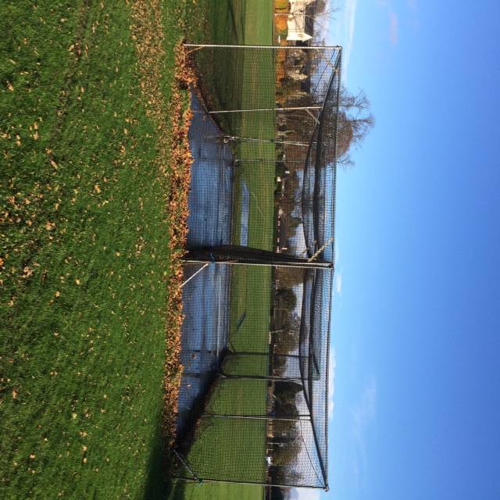

The photo shows that the current facilities are outdated and worn in places. Additionally, only one of the two available nets can be operated at any one time due to the protection and wellbeing of the players’ safety. Therefore, the new nets will allow us to use both nets simultaneously. Below is a diagram of the proposed new nets:
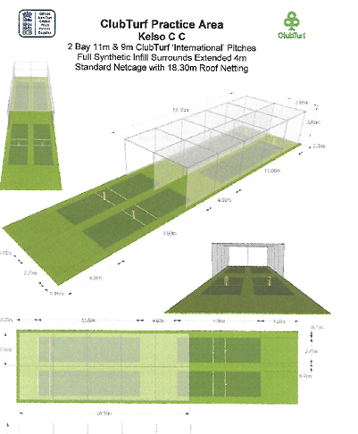

4. Strategic Context

The primary aims and objectives of our project are as follows :-

Increase Opportunities for Junior Players
- Upgraded net facilities will provide the perfect learning environment for newcomers to the game. Young players will have the opportunity to work on the core competencies of cricket using these facilities, as well as offering them a facility that allows the development of skills through match situations, scenario-based sessions and technical work. This will further improve the young players match preparation and continue to aid the development of the already growing junior set up at the club.
- Upgraded nets will provide safer practice facilities allowing more members to participate during sessions. Currently, the club can only operate one of the two available nets due to the protection and wellbeing of the children’s safety. Therefore, with new and safer practice facilities, this will provide the chance for the club to increase learning opportunities to a greater number of its junior members in one session. This potentially could have a positive effect on junior members at the club due to increased learning time.
- Modern practice facilities at the club will allow the opportunity for local schools to hold their own practice sessions at the club. Currently, the club are looking to set up closer relations with local primary/secondary schools and build on the success achieved through our Community Coach and Cricket Scotland school taster sessions. The development of the upgraded facilities will be an attractive incentive for these schools to build strong relationships with the club.

Increased Opportunities for Senior Players
- Kelso 1st XI will play in 2016 play in the East of Scotland Championship Division after four consecutive seasons of promotion. Therefore, with an increase in the standard of cricket played, the club feel it is appropriate to improve the facilities on offer to their members. Improved net facilities will allow the opportunity for elite performance development within the 1st XI squad, due to the improved facilities on offer to the team.
- Kelso 2nd XI play within the Sunday Border League, aimed at allowing the opportunity for players just emerging from the junior set-up to develop as cricketers at a more suitable adult level. The club already hold open adult training sessions on both Tuesdays and Thursdays throughout summer, however due to the protection and safety of club members, only one net can be operational during practice sessions. With upgraded facilities, players will have greater access to playing time within practice sessions. This in turn could potentially lead to more members at the club due to increased practice opportunities.

Growing and Sustaining Junior Cricket
- As previously stated, Kelso Cricket Club will look to implement more structured sessions through the new, improved net facilities at the club.
- It would also open up the opportunity for the Community Coach to run summer camps for local children. Kelso Cricket Club is a major supporter of the Spring/Summer Community Coach system as we believe that it provides a pathway for young people to get involved in cricket. We will then work hard to ensure that they return to the club looking to join as a full-time members. Currently the community coach visits schools and teaches on their playing fields/gym facilities, however improved net facilities will provide an ideal learning environment to introduce and develop the skills associated with the game of cricket to the children.

Bring new people to the game
- Kelso Cricket Club already have a growing number of junior members within the club and new memberships have steadily been increasing over the past three years. Firstly, upgraded net facilities will allow greater playing opportunities to these new members. To further this, locals within the area are likely to see these facilities in the area and may therefore be inclined to send their children or friends along to sessions, thus in turn introducing more people to the game.
- Kelso Cricket Club already have access to both a senior and junior bowling machine at the club, providing the perfect learning opportunity for new players to learn the core competencies of cricket with a consistent feed. However, without a safe learning environment such as upgraded net facilities, the club cannot use these assets to their maximum potential.
5. Project Delivery
Kelso Cricket Club plays its games at Shedden Park in Kelso, where the clubhouse and outfield maintenance are both self-managed by the club. Much like the rest of the clubs facilities, the new Practice facilities would be self-managed by the club and kept in top condition for all the cricket age groups to benefit from.
The Clubhouse is open to all playing and non-playing club members from April till the end of September and provides a social environment for these members to enjoy throughout the summer. The Clubhouse bar is an important part of the local community and is used for local events such as Family Day during Kelso Civic Week, as well as corporate social bookings such as the annual Plexus Summer Staff Party and various other community functions.
Throughout the summer, many different sections of the community use the facilities and equipment of the club and these include:-

- 1st XI Cricket team (East of Scotland Championship Division)
- 2nd XI Cricket team (Borders Reserve League)
- Kelso u14/16s (Border Junior Leagues)
- Kelso u8/10s (Border Kwik Cricket Festivals)
- Border Girls Squad Training sessions
- Pub League (local 8 a side teams on a Friday night)
- Local primary schools Kwik cricket festival
- Border and District matches
- Kelso Cricket Club function days/evenings eg. Bonfire night, local festivals, birthday bookings, fancy dress nights, corporate events

The use of this facility by these sectors brings in much needed income to the Club and provides us with extra resources to invest for the future. By constantly improving our facilities, we are ensuring the long term future of Kelso Cricket Club.

6. Project Resources
The committee will be responsible for a timely and cost-accurate delivery of the nets. Following this, the committee will then be responsible for the upkeep of the new facility, ensuring that any damage or renovation work in the future will be completed.
Kelso Cricket Club currently have three UKCC Level 2 cricket coaches. In addition to this, the Club are in the process of signing two overseas players for the 2016 season, who also both have a UKCC Level 2 equivalent coaching qualification. These five coaches will be responsible for educating the rest of the club on how to maximise the utility of the new facilities, by doing training sessions for all age groups at the start of the 2016 season. These five coaches are supported by a number of volunteer coaches, who will be jointly responsible for the delivery of weekly junior training sessions using the new facilities.
Additionally, the Community Coach will have access to the new facilities. As well as having the opportunity to use the new nets with local schools, we hope to organise summer cricket camps with the Community Coach which would provide a pathway for young people to get involved in cricket at Kelso.

7. Project Costs
Kelso Cricket Club have asked Nottssport Ltd and ClubTurf Cricket Limited to quote for new Practice Facilities to be installed in Spring 2016. Both are ECB/Cricket Scotland approved suppliers. Site visits have been made by both companies and the estimates given are as followed (see Appendix A) :-
Nottsport Ltd £24400 +VAT = £29280
ClubTurf Cricket Limited £21880 +VAT = £26256
Our supplier for the Artificial wicket in Spring 2015 was ClubTurf and we are very pleased with their product. Hence they are also our preferred supplier for this Project.
The cost of the new Practice Facilities and the Sightscreens will be £30000 including demolishing the existing structure. We have applied for a 50% Grant from the Sports Facilities Fund which leaves a short fall of £15000. Consequently, we have applied to the Sports Clubs Grant Scheme through the Borders Sport and Leisure Trust for an additional grant of £5000 and for a grant of £7000 from the Borders Community council fund.. This will leave £3000 (10% of the Project Cost) payable, which Kelso Cricket Club will finance out of its reserves. In the event that this form of funding is not successful, we will pursue other grant options with the help of our preferred installer.
As a last resort, the club has funds available (accounts and latest bank position attached at Appendix C) and will finance the project ourself but embark on extra fundraising during the 2016 season.
8. Financial Appraisal
 | 2015 | 2016 | 2017 | 2018 | 2019 | 2020
Income
Memberships | 1,790 | 4000 | 4200 | 4400 | 4600 | 4800
Sponsorship | 2,540 | 12500 | 13000 | 13500 | 14000 | 14500
Bar Net Income | 4,219 | 5000 | 5500 | 6000 | 6500 | 7000
Other Income | 16,445 | 32000 | 2000 | 2000 | 2000 | 2000
Grants for Pavilion Extension |  |  |  |  | 55000
 | 24,994 | 53500 | 24700 | 25900 | 77100 | 28300
Expenditure
Pavilion Upkeep | 959 | 1000 | 1200 | 1400 | 1600 | 2500
Capital Improvements | 13800 | 30000 |  |  | 65000
Ground Upkeep | 2,850 | 7000 | 3100 | 3200 | 3300 | 3400
Players & Travel Expenditure | 1,367 | 11500 | 6600 | 6700 | 6800 | 6900
Coaching / Kit | 1,633 | 2000 | 2100 | 2200 | 2300 | 2400
Other Overheads | 7389 | 7000 | 7000 | 7100 | 7200 | 7300
 | 27,998 | 58500 | 20000 | 20600 | 85200 | 22500
Net (Loss)/Profit | -£3,004 | -£5000 | £4700 | £5300 | -£4100 | £5800

 | 2015 | 2016 | 2017 | 2018 | 2019 | 2020
Net Assets Brought Forward | 22218 | 19214 | 14214 | 18914 | 24214 | 20114
(Loss)/Surplus for Year | -£3004 | -£5000 | £4700 | £5300 | -£4100 | £5800
Net Assets At Year End | 19214 | 14214 | 18914 | 24214 | 20114 | 25914

NOTES TO FORECASTS

1. 2015 figures are actual and were approved at the Club AGM in January 2016
2. 2016 figures include projected grants receivable and expenditure (£30k) on the proposed upgrading of the present practice area. In addition, historically our Members subscription rates have been very low compared to other Clubs , so these levels will be increased over the next 5 years.
3. 2016 figures include an extra £10k of sponsorship Income. The Club has developed a Sponsors document (see attached at Appendix 2) to sell to local businesses.
4. Ground upkeep expenditure in 2016 includes £4k of sign set up costs needed to get the advertising board infra structure set up for subsequent years.
5. Players expenses in 2016 includes additional costs for Lodging for 2 overseas players . This will be reduced to one player in subsequent years.
6. Capital improvements relate to the Artificial Wicket and Covers in 2015, the upgrade of the practice facilities in 2016 and the proposals for the clubhouse in 2019
7. Over the 5 year period, after all the Upgrading, we would expect the Club's net worth to increase over it's current level.

9. Marketing and Communications Strategy
Alongside the physical facility redevelopment plans, the committee is in the process of redeveloping the Club’s sponsorship and marketing capabilities. As part of the new sponsorship programme, the club will publish a sponsorship pack which will exhibit the redevelopment projects that the Club is undertaking. These sponsorship packs will be sent to local businesses around Kelso as a way of attempting to increase engagement between the Club and the local community. The proposed pack is attached at Appendix 2.
Alongside these efforts, the Club are going to increase their usage of social media to build on the successes of recent years. The Club has used Facebook more frequently over the last four seasons and have noted a significant increase in engagement with the local community. The committee plan to use Facebook and Twitter to show the different stages of the upgrading work, therefore giving an insight into the improvements that will be completed at the Club during the off-season. The committee hope that this will increase new members of all age ranges, as the facilities will become some of the best in the South of Scotland.
We hope that local schoolchildren will benefit from the new nets. The summer Kwik Cricket Festival, Community Coach sessions in PE classes and summer courses all offer us great opportunities to market the redevelopment projects at the Club and increase youth participation in sport.
Finally, the club plan to approach local newspapers to advertise the new facilities. Due to the large amount of redevelopment work being completed, the committee believe that it is important to showcase this to the local community.

10. Monitoring and Evaluation
We feel we will be able to monitor the positive externalities of the new facilities in three main ways. These are:
- Increase in the number of matches played by the club in total:
The new facilities in 2015 and proposed for 2016 will give more game opportunities to junior and senior members of the club, resulting in less cancellations throughout the summer
- Increase in the number of playing members:
With more and more opportunities to get involved within the club such as the introduction of the franchise Last Man Standing as well as an increase in summer Kwik Cricket festivals for children to get involved in, this is likely to lead to a high interest in people wanting to represent the senior teams in the club at weekends, as well as the junior sides throughout the week.
The tables below are an indication of how we envisage membership increasing over the next five years:-

2015 | Teams | Male Players | Female Players
Softball | As needed
U11 |  | 25 | 1
U13 | 1 | 21 | 0
U15 | 0 | 6
U18 | 1 | 12
Adult | 2 | 20
Total | 4 | 84 | 1

2020 Prediction | Teams | Male Players | Female Players
Softball | As needed
U11 |  | 40 | 5
U13 | 2 | 30 | 5
U15 | 1 | 12
U18 | 1 | 18
Adult | 2 | 35
Total | 6 | 135 | 10

- Increase in capital revenue generated by the club
With an increase in the number of matches played by the club, as well as more social short-format games such as Pub League cricket and Last Man Standing, this in turn is likely to see a greater turnover by the Clubhouse bar. More members will also generate higher revenue for the club, ensuring the long term sustainability of Kelso CC and giving the club the financial backing to grow through new investment in facilities and equipment.
The on field success of the Club has generated an increase in local business Sponsorship in 2015 and we intend to build on this in future years by providing more advertising opportunities for our supporters.

11. Risk Analysis
We have identified three key risks which are discussed in more detail below.
i) Weather damage
The current nets have been susceptible to damage from adverse weather conditions, as renovation works have been completed three times in recent years. The nets have been damaged because of the low quality materials used. We have been ensured by both of our suppliers that the new nets will withstand significant damage from weather.
ii) Participation levels
Our projections show a continued increase in participation across all age groups. However, these projections are based on recent history, and there is no guarantee that these trends will continue. The committee are confident that the redevelopment work being undertaken across all aspects of the Club will continue to attract new members.
iii) Delivery
Both of our suppliers and the committee are confident that they will be able to install the new nets before the start of the 2016 season. However there is always a chance of these types of projects being delayed by adverse weather conditions, unexpected additional requirements or delays from third party suppliers. Should one of these situations arise, the Club would experience issues with its training sessions due to a lack of adequate facilities. The committee will therefore ensure that they manage the installation of the new facilities based upon a measured timescale to the best of their ability, to ensure a delivery before the start of the 2016 season.

